

ADAS RECOMMENDED
TOOLS AND EQUIPMENT
Basic ADAS Tools
Image | Item | Link  *Preferred | Cost
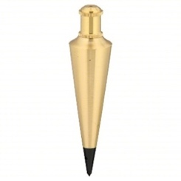 | Plumb Bob  -Recommend two but one will work | Amazon  Grainger | $10-20
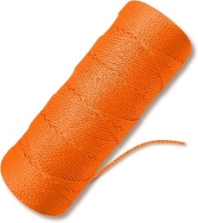 | String  -Used to string plumb bob and a straight line for static target placement | Grainger  Amazon | $7-12
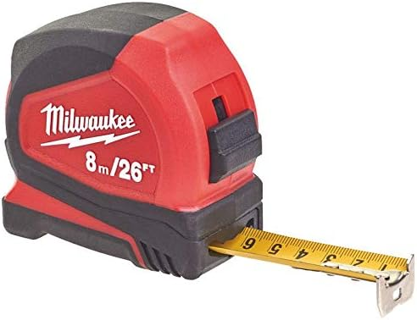 | Metric/Standard Tape Measure  -Recommend two but one will work | Grainger  Amazon | $25-30
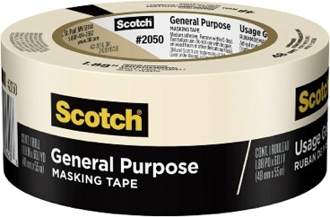 | Masking Tape  -Reach out to TCOE. We have you covered on this. | Grainger  Amazon | $5-7
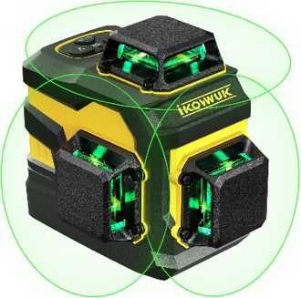 | Laser Level  -Recommend green lasers due to being more visible with 3 planes | Amazon*  Zoro | $100-320
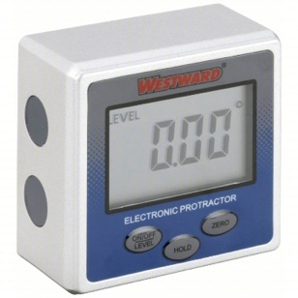 | Digital Angle Guage  -Used to diagnose radar mounting and floor-level  -Toyota Tool Kit Part # 11815-00009 | Grainger  Amazon | $26-175
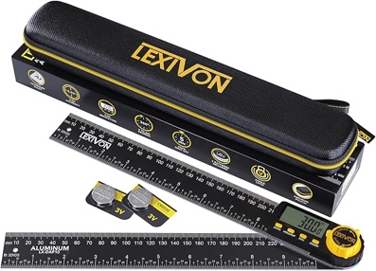 | Digital Protractor  -Used to measure angles for blind spot radar calibration | Grainger  Amazon* | $35-90
 | Large L Square  (optional)  -Useful for some forward-facing camera calibrations | Amazon* | $37
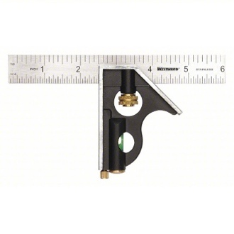 | Combination Square  (optional)  -Useful as a target for the laser | Grainger  Amazon* | $11-20
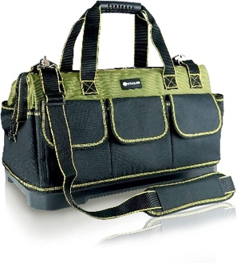 | Tool Bag  (optional)  -Keep your ADAS basic tools in one spot | Grainger  Amazon* | $26-75

Equipment
Image | Item | Link  *Preferred | Cost
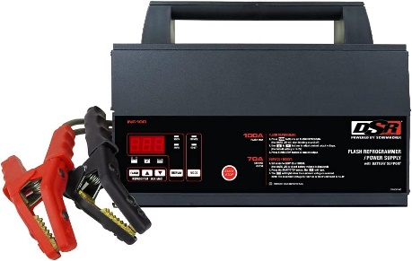 | Battery Maintainer  -At least 100-amp battery maintainer | Grainger  Amazon* | $420-900
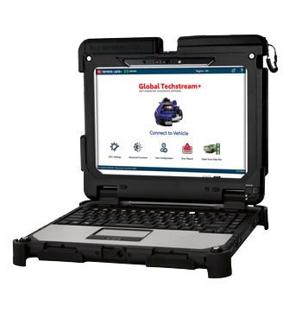 | OEM Factory Scan Tool  -Recommend OEM factory scan tool for the ADAS vehicle you plan on working on.  -OEM scan tools will always have the most functionality compared to aftermarket.  Example: Toyota TIS TechStream. | Toyota-TechStream | $6,330

Static ADAS Calibration Fixtures
There are many different ADAS static calibration fixtures on the market today, each with its pros and cons. Some are designed to integrate with your existing alignment machines, while others are designed to be used as a stand-alone after the alignment is completed. Below are some kits from different manufacturers.
Image | Item | Link | Cost
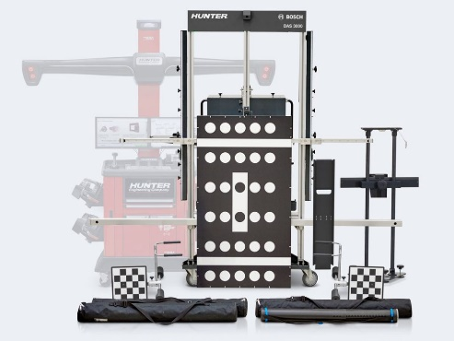 | Hunter DAS 3000  -Integrated with Hunter Hawkeye Aligner  -Comes with ADASLINK-associated diagnostic scan tool  -This is the Bosch system integrated into the Hunter alignment system | Hunter | $30K-40K  *These are estimates of costs found on the internet, not including education discounts
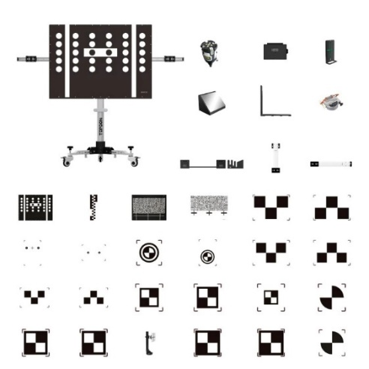  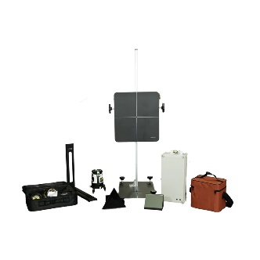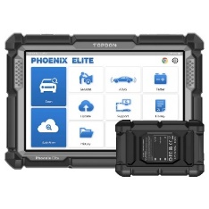 | TopDon Phoenix Mobile ADAS Basic Package  -Stand-alone  -Mobile design for space savings  -Scan tool not included  TopDon Radar 3-IN-1 Kit  -Kit required to calibrate radar  Phoenix Elite Scan tool  -Full-functioning scan tool  -Compatible with the fixture to perform ADAS calibrations  DNR Sales  (MN State Vendor)  Bruce Dodson  Cell:612-275-9438  Email: bmd@dnrsales.com | TopDon | Fixture  $8K-10K  Radar  3-IN-1 Kit  $3K  Scan tool  $1,700-2,000  *These are estimates of costs found on the internet, not including education discounts
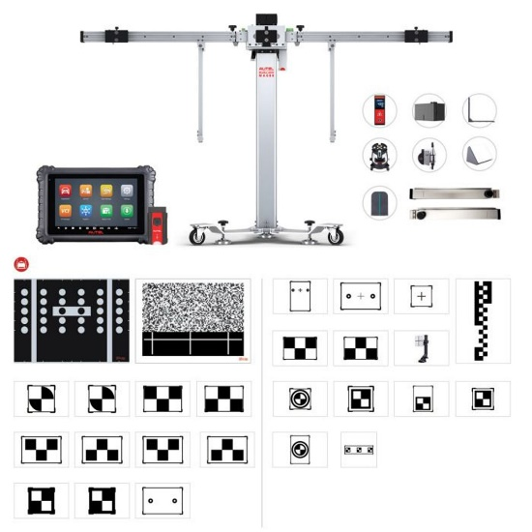 | Autel  MA600CORE2-ADAS-Package  -Stand-alone  -Comes with the associated scan tool | AESWave | $9K-12K  *These are estimates of costs found on the internet, not including education discounts
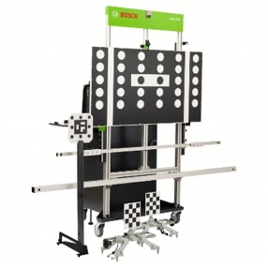 | Bosch  BOSDAS3000-1  -Stand-alone  -Comes with the associated scan tool | Bosch  Grainger | $30K-40K  *These are estimates of costs found on the internet, not including education discounts
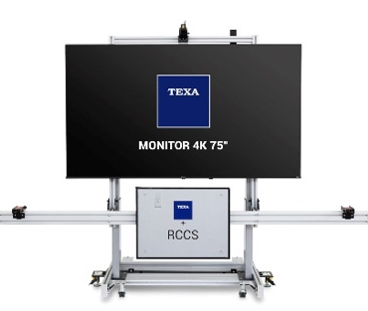  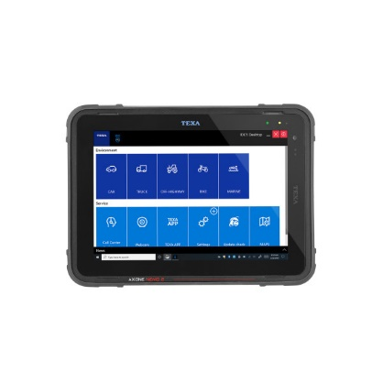 | TEXA  RCCS 3EVO  -Stand-alone  -Does not come with a scan tool  *Cool feature: Loads camera targets on monitor so no need to store some physical targets  TEXA NEMO 2 Scan Tool  -Full-functioning scan tool  -Able to connect to cars, trucks, motorcycles, and off-road equipment  TEXA Sales Manager  Joffrey Starcher  joffrey.starcher@texa.com | TEXA | FREE-Available as a “Can I Borrow That?” on our website.  Fixture  $35K-40K  Scan tool  $15-20K  *These are estimates of costs found on the internet, not including education discounts

Other Options….
If purchasing a complete ADAS fixture with all targets isn’t feasible, consider focusing on one vehicle. Buy the associated targets for that specific vehicle and use the factory scan tool. This approach will provide students with the basic skills and understanding of performing a calibration without the significant overhead of acquiring all targets for every make and model.
For example, the following targets are commonly used for most Toyota vehicles.
*Check service information for the correct target number and size.
Image | Item | Link | Cost
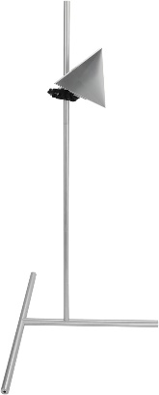 | Aftermarket Radar Target  -Compatible with Toyota, Honda, Fordm GM, Mazda, Kia and Hyundai  -Will calibrate front and side radars  -Toyota Part #:  Stand:  09870-60000  Radar Target:  09870-60040 | Amazon | $80
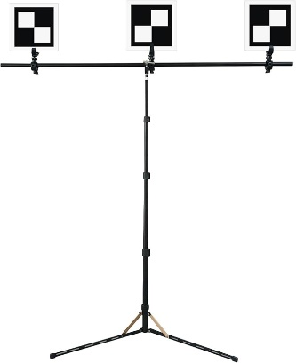 | Aftermarket Forward-facing Camera Toyota Target  -Toyota Part #:  Stand:  09870-60000  Stand Support:  09870-60060  Target Board No.1:  09870-61100  Sequential Target:  09870-62100  One-time Recognition Target:  09870-62200 | Amazon | $225

Other things to think about…
Proper shop space is essential for accurate static calibration. If you're designing a dedicated space for stand-alone ADAS static calibration, keep the following in mind:
- Level floors: Most manufacturers require no more than 0.4 inches of slop over an 8-foot span.
- Recommended clear space: 45 ft by 30 ft (minimum of 34 ft by 25 ft).
- Avoid direct sunlight, as it can cause glare on camera targets.
Ensure no distracting backgrounds, such as checkered patterns or high-contrast designs.
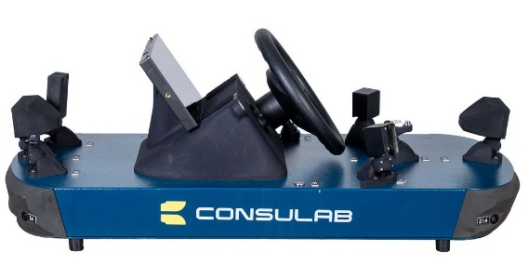  Consulab EV-360 | Consulab EV-360 ADAS Trainer  A great tool for demonstrating the ADAS perception systems (front camera, front radar, side radar, ultrasonic, backup camera, and lidar) to your students in a compact design.  For a quote, contact Mike Seegar at First Technologies Inc.  Mike.Seegar@firsteched.com
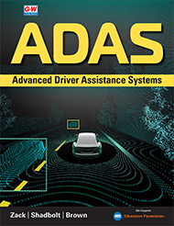  G-W ADAS | ADAS Textbook  G-W’s Textbook by Steve Zack, Kurt Shadbolt, and Scott Brown is a great resource to sharpen your skills in the ADAS world, everything you need to know to pass the ASE L4 ADAS advanced level specialist certification.  Contact Gail Worthman for more information:  gworthman@g-w.com

